[](http://www.google.co.uk/url?sa=i&rct=j&q=&esrc=s&source=images&cd=&cad=rja&uact=8&ved=0ahUKEwiw4O2mjeXUAhUEQBoKHcXRC-cQjRwIBw&url=http://www.wrexhammineralcables.com/&psig=AFQjCNFW5MKF4WnNdfKwjkJGi1r_Ph6j8w&ust=1498896068409353)[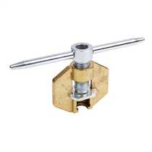](http://www.google.co.uk/url?sa=i&rct=j&q=&esrc=s&source=images&cd=&cad=rja&uact=8&ved=0ahUKEwjgzOC1i-XUAhVIAxoKHS67DL8QjRwIBw&url=http://www.cef.co.uk/catalogue/categories/mineral-insulated-cable-accessories-micc-tools&psig=AFQjCNHHYILP55T5Fcpi08a9RkffzYu-1A&ust=1498895599009506)[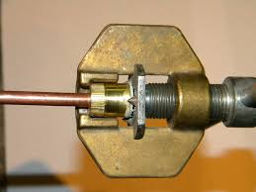](https://www.google.co.uk/url?sa=i&rct=j&q=&esrc=s&source=images&cd=&cad=rja&uact=8&ved=0ahUKEwiUk4SljOXUAhVB1hoKHWFoCTwQjRwIBw&url=https://www.diynot.com/diy/threads/micc-pyro.223016/&psig=AFQjCNHHYILP55T5Fcpi08a9RkffzYu-1A&ust=1498895599009506)

[](https://www.google.co.uk/url?sa=i&rct=j&q=&esrc=s&source=images&cd=&cad=rja&uact=8&ved=0ahUKEwiLnITdi-XUAhVINhoKHQrbBm4QjRwIBw&url=https://www.thesafetycentre.co.uk/store/fire_alarm_system_equipment/fire_alarm_installation_kit/fire_alarm_cable_installation_kit/micc_pyrotenax_cable_joistripper_tool.php&psig=AFQjCNHHYILP55T5Fcpi08a9RkffzYu-1A&ust=1498895599009506)[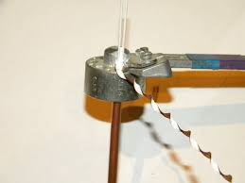](https://www.google.co.uk/url?sa=i&rct=j&q=&esrc=s&source=images&cd=&cad=rja&uact=8&ved=0ahUKEwiDkJm-jOXUAhUCnBoKHQmdCPcQjRwIBw&url=https://www.diynot.com/diy/threads/micc-pyro.223016/&psig=AFQjCNHHYILP55T5Fcpi08a9RkffzYu-1A&ust=1498895599009506)

[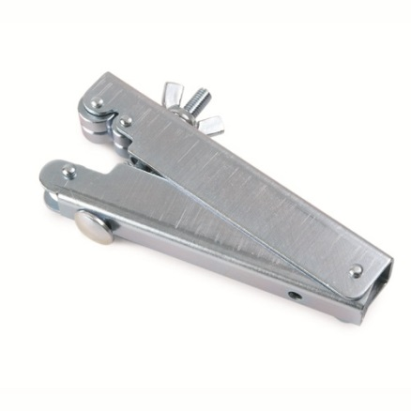](http://www.google.co.uk/url?sa=i&rct=j&q=&esrc=s&source=images&cd=&cad=rja&uact=8&ved=0ahUKEwin7_q_i-XUAhUFnRoKHYD2DeQQjRwIBw&url=http://www.remora.net/catalogue/MICC-cable-gland-fire-clips-tooling-gland-shrouds-saddle-clips-p-clips/MICC---Tooling&psig=AFQjCNHHYILP55T5Fcpi08a9RkffzYu-1A&ust=1498895599009506)[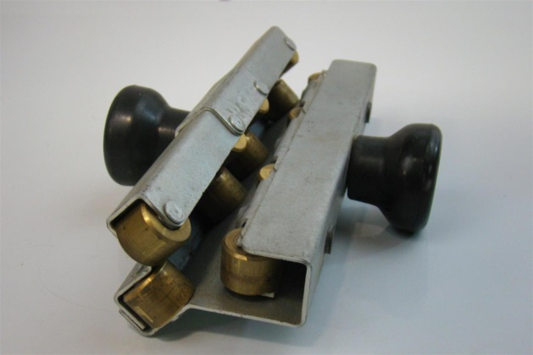](http://www.google.co.uk/url?sa=i&rct=j&q=&esrc=s&source=images&cd=&cad=rja&uact=8&ved=0ahUKEwjguLf0jOXUAhWGuBoKHeLBALIQjRwIBw&url=http://ebay.com/itm/pyrotenax-straightening-tool-pyro-roller-tool-cable-up-to-12-mm-/161186519459&psig=AFQjCNEwwopII8BpgE0_wC3ONXiFc85T-g&ust=1498896001679721)

[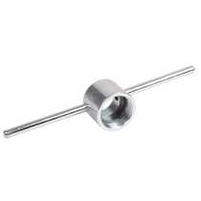](http://www.google.co.uk/url?sa=i&rct=j&q=&esrc=s&source=images&cd=&cad=rja&uact=8&ved=0ahUKEwjJ-43Ui-XUAhUEtRoKHdPuCQgQjRwIBw&url=http://www.cef.co.uk/catalogue/categories/mineral-insulated-cable-accessories-micc-tools&psig=AFQjCNHHYILP55T5Fcpi08a9RkffzYu-1A&ust=1498895599009506)

[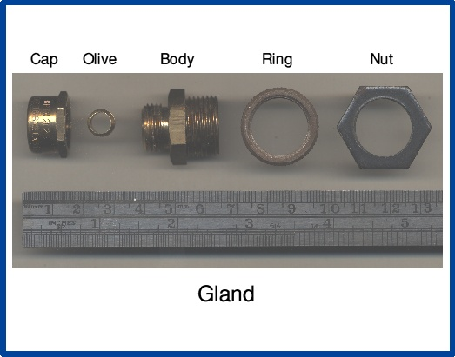](http://www.google.co.uk/url?sa=i&rct=j&q=&esrc=s&source=images&cd=&cad=rja&uact=8&ved=0ahUKEwjggebFjuXUAhXMuhoKHYkjCG8QjRwIBw&url=http://wiki.diyfaq.org.uk/index.php?title%3DTerminating_MICC_/_Pyro&psig=AFQjCNFW5MKF4WnNdfKwjkJGi1r_Ph6j8w&ust=1498896068409353)

[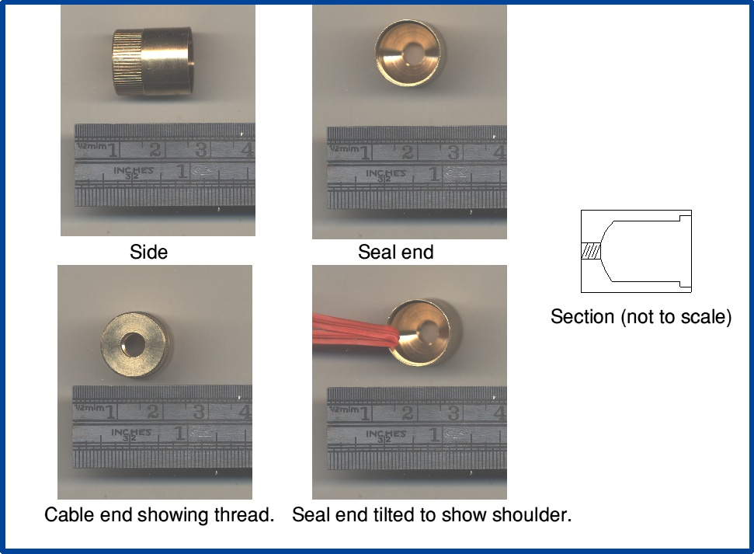](http://www.google.co.uk/url?sa=i&rct=j&q=&esrc=s&source=images&cd=&cad=rja&uact=8&ved=0ahUKEwiQ45b8juXUAhXEtBoKHfclC4AQjRwIBw&url=http://wiki.diyfaq.org.uk/index.php?title%3DTerminating_MICC_/_Pyro&psig=AFQjCNFW5MKF4WnNdfKwjkJGi1r_Ph6j8w&ust=1498896068409353)

[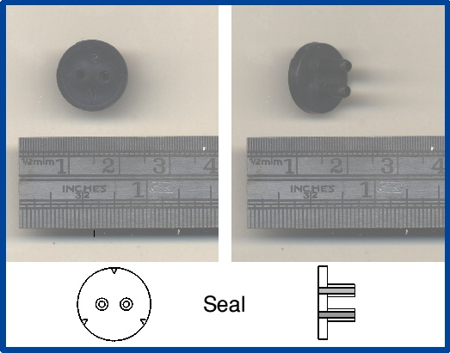](http://www.google.co.uk/url?sa=i&rct=j&q=&esrc=s&source=images&cd=&cad=rja&uact=8&ved=0ahUKEwj1lIyFj-XUAhUH1hoKHU7MAP0QjRwIBw&url=http://wiki.diyfaq.org.uk/index.php?title%3DTerminating_MICC_/_Pyro&psig=AFQjCNFW5MKF4WnNdfKwjkJGi1r_Ph6j8w&ust=1498896068409353)